Written Assignment Unit 3

An Assignment submitted in partial fulfillment of the requirements for the degree of
Bachelor of Science
in
Computer Science

CS 2204 – Communication and Networking
Term 1 - 2024
University of The People

September 25, 2024

- What do you understand by The Hidden Node Problem? Describe 2 different spatial configurations which exemplify this issue.
The Hidden Node Problem is a challenge in wireless networking where two or more devices are within range of a common access point, but not of each other. This leads to communication issues as these devices cannot detect each other's transmissions, potentially causing packet collisions when they try to send data simultaneously.
The first spatial configuration that exemplifies this issue is when two devices are positioned on opposite sides of a physical obstacle, like a wall or a building, with an access point located in between. Both devices can communicate with the access point but cannot detect each other's signals due to the obstacle (Dordal, 2023). This can result in both devices transmitting data at the same time, leading to packet collisions.
The second spatial configuration is when two devices are placed far apart in an open space, but still within the range of a common access point. Due to the distance between them, they cannot detect each other's transmissions (Dordal, 2023). Similar to the first scenario, this can lead to both devices transmitting data simultaneously, causing packet collisions at the access point. In both cases, the Hidden Node Problem reduces network efficiency and increases the likelihood of data retransmissions, leading to a decrease in overall network performance.
- What is the 4B/5B encoding for the 3-byte (ASCII) string “Sun”?
The 4B/5B encoding is a technique used to encode 4-bit data into 5-bit data for transmission. When applied to the ASCII string "Sun", the 4B/5B encoding results in the following sequence: 0101110101 0111101011 0111011100. This encoding ensures that the data can be transmitted reliably over communication channels, as it reduces the possibility of errors due to signal degradation or noise (Iyanda, 2023). In addition, the 4B/5B encoding ensures that the transmitted data maintains a balanced number of 0s and 1s, which is important for clock synchronization and data recovery at the receiver end (Iyanda, 2023).
- What is the 16-bit internet checksum for the 3-byte binary message 00110001 00110010 00110011?
To calculate the 16-bit internet checksum for the 3-byte binary message 00110001 00110010 00110011, the process involves performing a 1's complement addition of the three 8-bit numbers. First, we convert the binary groups into hexadecimal: 00110001 = 31, 00110010 = 32, and 00110011 = 33. Adding them in hexadecimal results in 31 + 32 + 33 = 96. In binary, this is 01101001. To compute the checksum, we invert the bits of this result, which gives 10011011. Thus, the 16-bit internet checksum for the message 00110001 00110010 00110011 is 10011011 11001101.
- Suppose a message is 11011000. What is the CRC checksum using the polynomial corresponding to 1011 to give a 3-bit answer? (Show the solution steps, not just the answer).
To compute the CRC checksum for the message 11011000 using the polynomial 1011, follow these steps:
Append zeros to the message: Since the divisor polynomial is of degree 3, append three zeros to the message, resulting in 11011000000.
Perform binary division: Divide 11011000000 by 1011 using modulo-2 division:
- First, align 1011 under the most significant bits of 11011000000.
- Perform XOR (binary subtraction without borrowing) for the division steps.
- Continue this until no further division is possible as show below.
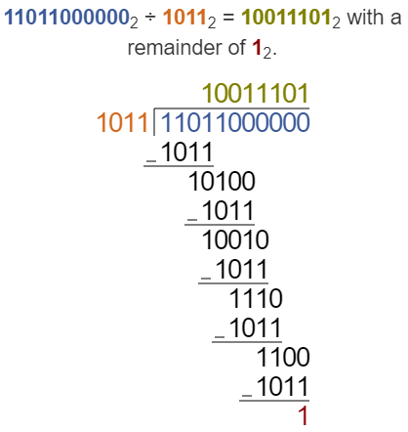
- What is Time Domain Reflectometry?
Time Domain Reflectometry (TDR) is a diagnostic technique used to locate and characterize impedance changes in a cable system. These changes may result from faults such as shorts, splices, open connections, or other anomalies like deteriorated neutrals or water ingress (Hernandez-Mejia, 2016). A TDR works by injecting a fast-rise pulse into one end of a cable system. As the pulse travels through the cable, any discontinuities or changes in the impedance cause reflections of the signal, which are then analyzed. The magnitude and timing of these reflected pulses help determine the nature and location of the discontinuities. The initial pulse and the reflected signals are displayed on a screen, similar to an oscilloscope, with the distance to the fault or discontinuity being calculated based on the speed of the pulse in the cable (Hernandez-Mejia, 2016). TDR is widely used in cable diagnostics due to its ability to identify faults and issues non-invasively​.
References
Dordal, P. (2023). An introduction to computer networks.
Hernandez-Mejia, J. P. (2016). Time domain reflectometry (TDR). https://bpb-us-w2.wpmucdn.com/sites.gatech.edu/dist/6/3800/files/2023/09/5-TDR_17_with-Copyright.pdf
Iyanda, J. (2023). Understanding and Paradigms of Hidden Node Problem, TDR, CRC Checksum and 4B/5B Encoding. https://rb.gy/mc0fyo

